Operator Overloading:

1. What are the benefits and drawbacks of operator overloading?

Benefits:

By overloading standard operators on a class you can exploit the intuition of the users of that class.

Drawbacks:

It has the potential to make your code less readable by others who is unfamiliar with these overloads.

1. Can you overload the assignment operator (=) in C++? If so, how would you ensure proper behavior?

In C++, you can overload the assignment operator (=) to define custom behavior for copying objects of a class. This is particularly important for classes that manage resources such as dynamic memory, file handles, or other resources that require deep copying.

To ensur proper behaviour we have to follow some steps:

• Self-assignment Check: Prevents the object from assigning itself, which can lead to resource management issues.

• Resource Management: Properly release existing resources before acquiring new ones to avoid memory leaks.

• Deep Copy: Ensure that a deep copy of resources is made to avoid shared resource issues.

1. Explain the difference between member function and non-member (friend) function overloading for operators?

A member function is declared in the class but defined outside the class and is called using the object of the class. A non-member function that is declared outside the class but call a normal function inside the main function.

1. Design a class Vector2D and overload the arithmetic operators (+, -, *, /) for vector addition, subtraction, scalar multiplication, and division (by a scalar).

Is it possible to overload the comparison operators (==, !=, <, >, <=, >=) for custom classes? If so, what considerations should be taken into account?

Yes we can design a Vector2D class in C++ and overload the arithmetic operators (+, -, *, /) for vector addition, subtraction, scalar multiplication, and division (by a scalar):

Code:

#include <iostream>

class Vector2D {

private:

double x, y;

public:

Vector2D() : x(0.0), y(0.0) {}

Vector2D(double x, double y) : x(x), y(y) {}

Vector2D operator+(const Vector2D& other) const {

return Vector2D(x + other.x, y + other.y);

}

Vector2D operator-(const Vector2D& other) const {

return Vector2D(x - other.x, y - other.y);

}

Vector2D operator*(double scalar) const {

return Vector2D(x * scalar, y * scalar);

}

Vector2D operator/(double scalar) const {

if (scalar != 0.0)

return Vector2D(x / scalar, y / scalar);

else

throw std::invalid_argument("Division by zero");

}

void display() const {

std::cout << "(" << x << ", " << y << ")" << std::endl;

}

};

int main() {

Vector2D v1(3.0, 4.0);

Vector2D v2(1.5, 2.5);

Vector2D sum = v1 + v2;

std::cout << "Sum: ";

sum.display();

Vector2D diff = v1 - v2;

std::cout << "Difference: ";

diff.display();

Vector2D scaled = v1 * 2.0;

std::cout << "Scaled: ";

scaled.display();

Vector2D divided = v1 / 2.0;

std::cout << "Divided: ";

divided.display();

return 0;

}

yes, it is possible to overload comparison operators (==, !=, <, >, <=, >=) for custom classes in C++. These operators allow you to define how objects of your class should be compared.

When overloading comparison operators for custom classes, consider the following:

1. **Semantics of Comparison**: Define what it means for two objects of your class to be equal (==), not equal (!=), greater than (>), less than (<), greater than or equal to (>=), and less than or equal to (<=).
2. **Consistency**: Ensure that the comparison operators are consistent with each other and with your class's behavior. For example, if == returns true for two objects, != should return false, and vice versa.
3. **Efficiency**: Implement comparison operators efficiently, especially for large data structures or classes that involve complex comparisons. Prefer const-correctness and pass arguments by const reference where appropriate to avoid unnecessary copies.
4. **Global vs Member Function Overloading**: Comparison operators can be overloaded as member functions or as global functions. Member function overloading typically involves comparing the current object (this) with another object passed as a parameter. Global function overloading allows comparisons where the left-hand side operand is not an instance of the class.
5. **Friendship**: Depending on your class's design, you may need to declare the comparison operators as friend functions to access private members if necessary.
6. Discuss the potential ambiguity that could arise when overloading the subscript operator ([]) for a class. How can this ambiguity be resolved?

To resolve this ambiguities we need to follow some steps:

Clear Semantics-Ensure that the subcript operator’s behaviour is clearly defined in the context of tour class.

Index Range Handling-Implement bounds checking if necessary to handle out-of-range access gracefully,possibly throwing exceptions or returning default values.

1. Can operator overloading be used to implement the concept of immutability (unchanging state) for a class? Explain your answer.

When overloading operators, what are some best practices to ensure code clarity and maintainability?

Yes, operator overloading in C++ can be used to enforce immutability for a class.

In C++, you can overload operators as member functions or global functions. When designing an immutable class:

1. Member Function Approach: Define operators as member functions. Ensure that these functions do not modify the internal state of the object but instead return a new object with the desired operation's result.

class ImmutableNumber {

private:

int value;

public:

ImmutableNumber(int val) : value(val) {}

ImmutableNumber operator+(const ImmutableNumber& other) const {

return ImmutableNumber(value + other.value);

}

int getValue() const {

return value;

}

};

int main() {

ImmutableNumber num1(5);

ImmutableNumber num2 = num1 + ImmutableNumber(3);

std::cout << "num1 value: " << num1.getValue() << std::endl; // Output: num1 value: 5

std::cout << "num2 value: " << num2.getValue() << std::endl; // Output: num2 value: 8

return 0;

}

2. Global Function Approach: Overload operators as global functions to achieve similar immutability. Ensure that these functions do not modify their arguments but return a new object with the desired result.

class ImmutableNumber {

private:

int value;

public:

ImmutableNumber(int val) : value(val) {}

friend ImmutableNumber operator+(const ImmutableNumber& num1, const ImmutableNumber& num2) {

return ImmutableNumber(num1.value + num2.value);

}

int getValue() const {

return value;

}

};

int main() {

ImmutableNumber num1(5);

ImmutableNumber num2 = num1 + ImmutableNumber(3);

std::cout << "num1 value: " << num1.getValue() << std::endl; // Output: num1 value: 5

std::cout << "num2 value: " << num2.getValue() << std::endl; // Output: num2 value: 8

return 0;

}

Function Overloading:

* 1. What is the core concept behind function overloading?

It is a feature of oops where two or more functions can have the same name but different parameters.It follows a simple principle and makes sure that the function name remains the same , whereas the list of arguments and their datatypes

varies. When a function is overloaded and is called in the main program if the set and type of input actual parameters match the syntax of the formal arguments then the function execution will happen.If the exact match is not found then the promotion of data types takes place such as float converting into double and I this case it given error.

* 1. How does the compiler differentiate between overloaded functions with the same name?

A compiler differentiates between overloaded functions with the same name using their signatures which include the function name and their number,type and order of their parameters.This process is also known as function overloading resolution.

* 1. Can functions with different return types be overloaded? Explain your reasoning?

Function overloading is unaffected by a function’s return type.Therefore the same function with a different return type will not be overloaded.

Code:

It is showing us that the function overloading fails if return type are different:

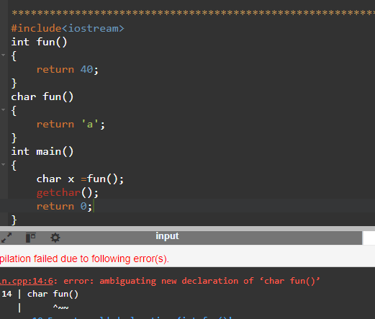

* 1. Design a function printValue that can handle different data types (e.g., int, double, std::string) by overloading it with appropriate parameter lists.

#include<iostream>

#include<string>

using namespace std;

void printvalue(int value)

{

cout<<"Integer value: "<<value<<endl;

}

void printvalue(double value)

{

cout<<"Double value: "<<value<<endl;

}

void printvalue(const std::string& value)

{

cout<<"String value: "<<value<<endl;

}

int main()

{

int intvalue = 42;

double doublevalue = 3.14;

std::string stringvalue = "Hellow Souvik";

printvalue(intvalue);

printvalue(doublevalue);

printvalue(stringvalue);

return 0;

}

Output:

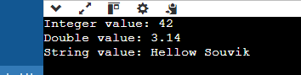

* 1. Discuss the advantages and disadvantages of using default arguments in overloaded functions?

Advantages:

It might lessen the requirment for function overloading.You can offer default values for optional parameters in a single function rather than having many overloaded functions with distinct parameters lists.

Disadvantages:

The compiler needs more time to execute the program.It uses the extra time to replace the remaining arguments with their default value during the function call.

* 1. In the context of function overloading, explain the concept of argument promotion and implicit type conversion?

Function overloading is a feature in many programming that allows multiple functions to have the same name but different parameters.

Argument promotion: It is also known as type promotion is the automatic conversion of smaller or less precise data types to larger or more precise ones.

This usually happens to match the expected data types of function parameters in overloaded functions.

Example- ‘char’ and ‘short’ are promoted to ‘int’ when passed a function.

Implict Type Conversion: It is also known as coercion is the automatic conversion of one data type to another by the compiler.This happens when the types of arguments passed to a function do not exactly match the types of the function’s parameters but can be converted to a compatible type.

Example-Converting an ‘int’ to ‘float’.

* 1. When might it be a better idea to use separate functions with descriptive names instead of overloading a single function?

Using separate functions with descriptive names instead of overloading a single function can be a better approach in several scenarios where clarity, maintainability, or explicitness are prioritized:

1. **Distinct Functionality**
2. Complex or Specialized Logic
3. **Avoiding Ambiguity**:
4. **Clarity and Readability**:
5. Ease of Maintenance
   1. Can function overloading be used to achieve polymorphism (the ability to treat objects of different derived classes in a similar way)? Explain.

Function overloading in C++ is a feature that allows multiple functions with the same name but different parameter lists to coexist within the same scope. While function overloading is related to polymorphism, it is distinct from polymorphism achieved through inheritance and virtual functions (runtime polymorphism).

**Function Overloading**:

* **Compile-Time Polymorphism**
* **Static Binding**.
* **Same Function Name**
* void process(int num) {
* std::cout << "Processing integer: " << num << std::endl;
* }
* void process(double num) {
* std::cout << "Processing double: " << num << std::endl;
* }

**Polymorphism (Through Inheritance and Virtual Functions)**:

* **Runtime Polymorphism**
* **Dynamic Binding**
* **Derived Class Usage**.

class Shape {

public:

virtual void draw() {

std::cout << "Drawing shape" << std::endl;

}

};

class Circle : public Shape {

public:

void draw() override {

std::cout << "Drawing circle" << std::endl;

}

};

class Square : public Shape {

public:

void draw() override {

std::cout << "Drawing square" << std::endl;

}

};

* 1. Describe a scenario where overloading a function with a variable number of arguments (varargs) could be beneficial?

### Logging Function with Varargs Overloading

Consider a logging utility function that needs to log messages of various types and formats to different destinations (e.g., console, file). Varargs overloading can be useful here to provide a single interface for logging different types of data with varying numbers of arguments:

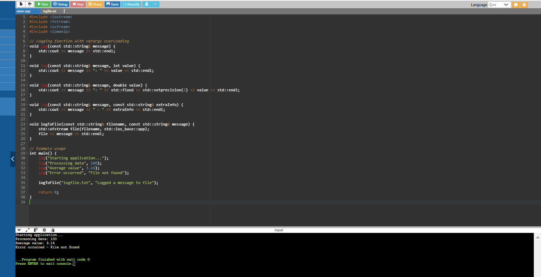

In this scenario, varargs overloading simplifies the interface for logging messages with various content types and formats, enhancing flexibility and maintainability in logging functionality within the application.

* 1. Compare and contrast function overloading with virtual functions in C++ inheritance. Which approach is more suitable for specific use cases?

Function overloading and virtual functions in C++ inheritance serve different purposes and are suitable for different use cases, depending on the design goals and requirements of your application.

**Function Overloading:**

**1.Purpose**:

* **Compile-Time Polymorphism**: Function overloading provides a way to define multiple functions with the same name but different parameter lists within the same scope.
* **Static Binding**: The specific function to be called is determined by the compiler based on the arguments passed at compile time.

**2**. • **Use Cases**:

* **Handling Different Argument Types**: Function overloading is useful when you want to provide multiple implementations of a function that operate on different types or numbers of arguments.
* **Enhancing Code Readability**: It improves code readability by allowing intuitive function names that reflect their intended operations.

Virtual Functions in C++ Inheritance:

**1.Purpose**:

* **Runtime Polymorphism**: Virtual functions enable polymorphic behavior, where the specific function to be executed is determined at runtime based on the actual object type.
* **Dynamic Binding**: The function call is resolved dynamically during runtime, allowing objects of different derived classes to be treated uniformly through base class pointers or references.

**2.Use Cases**:

• **Implementing Polymorphism**: Virtual functions are used to define a common interface in a base class that can be overridden in derived classes to provide specific implementations.

• **Enabling Object-Oriented Design Principles**: They facilitate principles like inheritance, abstraction, and polymorphism, allowing for more flexible and extensible code designs.

Function overloading and virtual functions in C++ inheritance serve different purposes and are suitable for different use cases, depending on the design goals and requirements of your application. Here's a comparison and contrast of both approaches:

**Function Overloading:**

1. **Purpose**:
   * **Compile-Time Polymorphism**: Function overloading provides a way to define multiple functions with the same name but different parameter lists within the same scope.
   * **Static Binding**: The specific function to be called is determined by the compiler based on the arguments passed at compile time.
2. **Use Cases**:
   * **Handling Different Argument Types**: Function overloading is useful when you want to provide multiple implementations of a function that operate on different types or numbers of arguments.
   * **Enhancing Code Readability**: It improves code readability by allowing intuitive function names that reflect their intended operations.

**Virtual Functions in C++ Inheritance:**

1. **Purpose**:
   * **Runtime Polymorphism**: Virtual functions enable polymorphic behavior, where the specific function to be executed is determined at runtime based on the actual object type.
   * **Dynamic Binding**: The function call is resolved dynamically during runtime, allowing objects of different derived classes to be treated uniformly through base class pointers or references.
2. **Use Cases**:
   * **Implementing Polymorphism**: Virtual functions are used to define a common interface in a base class that can be overridden in derived classes to provide specific implementations.
   * **Enabling Object-Oriented Design Principles**: They facilitate principles like inheritance, abstraction, and polymorphism, allowing for more flexible and extensible code designs.

**Suitability for Specific Use Cases:**

* Function Overloading:
  + Suitable For: Handling different behaviours based on different argument types or numbers.
  + Advantages: Enhances code readability and simplicity for operations with varied parameters.
  + Limitations: Limited to static binding, which means decisions are made at compile time based on the function call context.
* Virtual Functions:
  + Suitable For: Enabling polymorphic behaviour across derived classes, where the behaviour can vary based on the actual object type.
  + Advantages: Supports runtime polymorphism, facilitating flexible and extensible designs through inheritance.
  + Limitations: Introduces overhead due to dynamic dispatch, which can impact performance in certain contexts.

Choosing Between Them:

* If your goal is to provide different implementations based on the types or number of arguments passed, function overloading is typically more appropriate due to its simplicity and compile-time resolution.
* If you need to model hierarchical relationships and polymorphic behavior across classes, virtual functions in inheritance are essential for achieving runtime polymorphism and treating objects of different derived classes uniformly through base class interfaces.